**DEVELOPMENT PROJECT**

assessment instrument

**APPLY PRINCIPLES OF CREATING COMPUTER SOFTWARE BY DEVELOPING A COMPLETE PROGRAMME TO MEET GIVEN BUSINESS SPECIFICATIONS**

**US ID:** 115392 **NQF LEVEL:** 5 **CREDITS:** 12 **NOTIONAL HOURS:** 120

**DEMONSTRATE AN UNDERSTANDING OF ESTIMATING A UNIT OF WORK AND THE IMPLICATIONS OF LATE DELIVERY**

**US ID:** 114059 **NQF LEVEL:** 5 **CREDITS:** 5 **NOTIONAL HOURS:** 50

**APPLY PRINCIPLES OF DESIGNING COMPUTER SYSTEM INPUTS AND OUTPUTS**

**US ID:** 115365 **NQF LEVEL:** 5 **CREDITS:** 7 **NOTIONAL HOURS:** 70

**APPLY ADVANCED HTML AND ASSOCIATED TECHNIQUES TO BUILD A WEBSITE FOR BUSINESS APPLICATIONS**

**US ID:** 115368 **NQF LEVEL:** 5 **CREDITS:** 12 **NOTIONAL HOURS:** 120

**TEST A COMPUTER PROGRAM AGAINST A GIVEN SPECIFICATION**

**US ID:** 115384 **NQF LEVEL:** 5 **CREDITS:** 6 **NOTIONAL HOURS:** 60

**PRODUCE COMPUTER PROGRAM DOCUMENTATION TO AGREED STANDARDS**

**US ID:** 115388 **NQF LEVEL:** 5 **CREDITS:** 3 **NOTIONAL HOURS:** 30

SECTION A: FORMATIVE ASSESSMENT

*Answer the following questions;*

**Module 1 Formative Assessment (Unit Standard 115392)**

**Apply principles of creating computer software by developing a complete programme to meet given business specifications**

**Question 1 (5)**

Write a program to converts temperature from Fahrenheit to degrees in Celsius.    
Test Data  
Input a degree in Fahrenheit: 212  
Expected Output :  
212.0 degree Fahrenheit is equal to 100.0 in Celsius

*Please paste your code and a unit test of the calculation function here:*

**Question 2 (5)**

Write a program that reads a number in inches and converts it to meters.    
Note: One inch is 0.0254 meter.  
Test Data  
Input a value for inch: 1000  
Expected Output:   
1000.0 inch is 25.4 meters

*Please paste your code and a unit test of the calculation function here:*

**Question 3 (4)**

Write a program that prints the current time in GMT.

Test Data  
Input the time zone offset to GMT  
Expected Output:   
Current time is 23:40:24

*Please paste your code here:*

**Question 4 (7)**

Write a program to takes the user input for a distance (in meters) and the time was taken (as three numbers: hours, minutes, seconds), and display the speed, in meters per second, kilometres per hour and miles per hour (hint: 1 mile = 1609 meters).

Test Data  
Input distance in meters: 2500   
Input hour: 5   
Input minutes: 56  
Input seconds: 23  
Expected Output:   
Your speed in meters/second is 0.11691531   
Your speed in km/h is 0.42089513   
Your speed in miles/h is 0.26158804

*Please paste your code and a unit test of the calculation function here:*

**Question 5 (3)**

Write a C# program to print 'Hello' on screen and then print your name on a separate line.    
Expected Output:   
Hello   
Alexandra Abramov

*Please paste your code here:*

**Question 6 (6)**

Write a program to print the sum (addition), multiply, subtract, divide and remainder of two numbers.    
Test Data:   
Input first number: 125  
Input second number: 24

Expected Output:   
125 + 24 = 149  
125 - 24 = 101  
125 x 24 = 3000  
125 / 24 = 5  
125 % 24 = 5

*Please paste your code and one unit test per calculation function here:*

**Module 2 Formative Assessment (Unit Standard 114059)**

**Demonstrate an understanding of estimating a unit of work and the implications of late delivery**

**Question 1 (SO 1, AC 1)**

Define cost/benefit analysis (2)

**Question 2 (SO 1, AC 2)**

Identify and explain the different components of a cost benefit analysis (8)

**Question 3 (SO 4, AC 2)**

Explain the implications of late delivery on time and cost of a project (6)

**Module 3 Formative Assessment (Unit Standard 115365)**

**Apply the principles of designing computer system inputs and outputs**

**Question 1 (SO 1, AC 1)**

1. Explain the principles of computer input and output design. (6)
2. Identify the types of inputs and outputs. (6)

**Question 2 (SO 1, AC 2)**

Distinguish between the appearance and underlying structure and process in computer input and output designs. (8)

**Question 3 (SO1, AC 3)**

Explain the purpose of user involvement in creating input and output designs. (4)

**Question 4 (SO 1, AC 4)**

Compare online computer functions with manual and offline data entry. (5)

**Question 5 (SO 1, AC 5)**

Compare graphical input and output functions with text based input and output functions. (4)

**Module 4 Formative Assessment (Unit Standard 115368)**

**Apply advanced HTML and associated techniques to build a web site for business applications**

**Question 1 (SO 1, AC 1, 2)**

1. Identify advanced HTML features. (4)
2. Describe the use of the features that you identified above. (8)

**Question 2 (SO 1, AC 4)**

Explain the use of Dynamic HTML and XML. (8)

**Question 3 (SO 1, AC 5, 6)**

1. Identify and describe Dynamic HTML concepts. (8)
2. Identify and describe XML concepts. (6)

**Question 4 (SO 2, AC 1, 2)**

1. Explain the usage of CGI. Use a diagram to illustrate. (8)
2. Describe the types of services provided by a database backed website. (6)

**Module 5 Formative Assessment (Unit Standard 115384)**

**Test a computer program against a given specification**

**Question 1 (SO 1, AC 4)**

1. Define the term computer program testing. (2)
2. Explain the reasons why a developer must follow standards and procedures specified in the test plan for testing and retesting. (4)

**Question 2 (SO 2, AC 1)**

List records that a developer must create to capture results from a testing computer program. (4)

**Question 3 (SO 3, AC 1)**

Explain what a developer must check when reviewing the testing process for a computer program. (4)

**Module 6 Formative Assessment (Unit Standard 115388)**

**Produce documentation for a computer program to agreed standards**

**Question 1 (SO 1, AC 1)**

Identify and describe the key elements that must be covered in the design of a computer program document. (8)

**Question 2 (SO 1, AC 2)**

List the program documentation components that the documentation plan must cover. (8)

SECTION B: SUMMATIVE ASSESSMENT

Perform the following activities along with their related tasks.

Each task is specified as a GROUP or INDIVIDUAL activity.

Please follow these guidelines.

As an overview, these are the activities and tasks in this summative assessment:

Activity 1 – Planning the Project

Task 1 (US 115392: SO 1, AC 1, 2, 3, 4) [INDIVIDUAL WORK]

Task 2 (US 114059: SO 4, AC 1) [GROUP WORK]

Task 3 (US 114059: SO 2, AC 1, 2) [GROUP WORK]

Task 4 (US 114059: SO 3, AC 1, 2) [GROUP WORK]

Activity 2 – Design the Software

Task 1 (US 115392: SO 2, AC 1, 2, 3, 4) [GROUP WORK]

Task 2 (US 115365: SO 2, AC 1, 3) [GROUP WORK]

Task 3 (US 115365: SO 2, AC 2) [INDIVIDUAL WORK]

Activity 3 – Building the Software

Task 1 (US 115392: SO 3, AC 1, 2, 3) (US 115365: SO 3, AC 1, 2) [GROUP WORK]

Task 2 (US 115365: SO 3, AC 1, 2) [INDIVIDUAL WORK]

Task 3 (US 115368: SO 1, AC 3, 7) [INDIVIDUAL WORK]

Task 4 (US 115368: SO 2, AC 3, 4) [INDIVIDUAL WORK]

Activity 4 – Testing

Task 1 (US 115392: SO 4, AC 1, 2) [GROUP WORK]

Task 2 (US 115384: SO 1, AC 1, 2, 3, 4) [INDIVIDUAL WORK]

Task 3 (US 115384: SO 2, AC 1, 2, 3, 4) (US 115392: SO 4, AC 3) [INDIVIDUAL WORK]

Task 4 (US 115384: SO 3, AC 1, 2) [INDIVIDUAL WORK]

Activity 5 – Implementation / Installation

Task 1 (US 115392: SO 5, AC 1) [INDIVIDUAL WORK]

Task 2 (US 115392: SO 5, AC 2) [INDIVIDUAL WORK]

Task 3 (US 115392: SO 5, AC 3) [INDIVIDUAL WORK]

Activity 6 - Documentation

Task 1 (US 115392: SO 6, AC 1, 2, 3, 4) (US 115388: SO 2, AC 1, 2, 3) [GROUP WORK]

Task 2 (US 115388: SO 3, AC 1, AC 2) [INDIVIDUAL WORK]

|  |
| --- |
| **DECLARATION OF GROUP WORK:**  The tasks labelled as GROUP WORK were performed as a group with the following learners:   * Name: _____________________________ ID: _____________________________ * Name: _____________________________ ID: _____________________________   Learner Name: _____________________________ Signed: _____________________________  Date: _____________________________ |

## Activity 1 – Planning the Project

### Task 1 (US 115392: SO 1, AC 1, 2, 3, 4) [INDIVIDUAL WORK]

You have been given a software project assignment.

1. Identify and describe the problem that the business is facing. (4)
2. Interpret the problem facing the business and create a plan to develop a computer program solution. The plan must;
3. Propose a description of the problems to be solved by the development of the computer program.
4. Integrate the research of problems in terms of data and functions.
5. Include an evaluation of the viability of developing a computer program to solve the problem identified and compares the costs of developing the program with benefits to be obtained from the program *(Use the costing information gathered in Task 4 for this comparison)*
6. Choose the best solution to the problem and document the program features that will contain the capabilities and constraints to meet the defined problem. (16)

### Task 2 (US 114059: SO 4, AC 1) [GROUP WORK]

You are required to draw up a Work Breakdown Structure WBS to reduce the element of late work delivery on your project

1. Define the purpose of your Work Breakdown Structure (3)

Answer

The WBS is a project view that demonstrates what the project entails. This is a method that helps to convey the work and procedures involved in implementing the project with ease. The project manager and project team use the WBS to build project plan, resource and cost requirements.

1. Decompose your project into small manageable components (10)

Answer

*[see WBS diagram]*

1. Your WBS must show that the element delivered is often a subset of a bigger deliverable. (3)

Answer

*[see WBS diagram]*

1. Explain the reasons behind decomposing your project (4)

Answer

* For project visibility and also to show tasks at their simplest form which makes it easier to manage and helps prevent the project from slipping through the cracks.
* It guides the team into what needs to be done in an organized way.
* To provide base understanding within the team members with how the pieces all fit together into the overall project which makes it easier to track progress.
* Decomposing the project also helps in providing the basis for cost, staff, time and resource estimation, this is very useful in small batches as compared to large batches (big amount of work) or undecomposed project. The more granular and detailed the WBS, higher is the level of accuracy of the estimates.
* makes the tasks build meaning and be understandable as assignable efforts than can be tracked down and reported.

**Work Breakdown Structure**

AskAMech. System

1

Problem Definition

1.1

System Analysis

1.2

System Design

1.3

System Dev & Testing

1.4

Create Preliminary Scope Statement

1.2.1

Implementation (Closeout)

1.5

Gather Data

1.1.1

Feasibility Study

1.1.2

Study Existing Systems

1.2.2

Project Team Kickoff Meeting

1.2.3

Develop Project Plan

1.2.4

Submit Project Plan

1.2.4.1

Milestone: Project Plan Approved

1.2.5

Project Kickoff Meeting

1.3.1

Input and Output diagrams

1.3.2

Wireframes (Menus & Screens)

1.3.2.1

Ad hoc queries

1.3.2.2

Processing and Database

1.3.3

User Training

1.4.5

Go Live

1.4.6

Project Management

1.4.1

Project Status Meetings

1.4.2

Develop system & Testing

1.4.3

Testing Documentation

1.4.3.1

User Documentation

1.5.1

Document Lessons Learned

1.5.2

Update Files/ Records

1.5.3

Gain Formal Acceptance

1.5.4

Archive Files/ Documents

1.5.5

Install Live System

1.4.4

### Task 3 (US 114059: SO 2, AC 1, 2) [GROUP WORK]

For your software project assignment you are required to provide a time estimate for the project.

1. Breakdown the components of the project to be run in the logical parts for estimating (use the WBS from Task 2 above)
2. Estimate your time based on the main deliverables and the other components

(Use a pert chart and a WBS to estimate the time to complete the project)

**Note:** Attach all relevant evidence in the POE guide. (15)

### Task 4 (US 114059: SO 3, AC 1, 2) [GROUP WORK]

For your software project assignment you are required to estimate the cost of the project.

1. Breakdown the main deliverables into logical components for easy estimating (use the WBS from Task 2 above)

Answer

**System Analysis**

* Develop project plan

**System Design**

* Design system Architecture
* Development
* Software licensing
* System development
* Travel to client
* Internet connection
* Equipment
* Hosting
* Development team salaries

**System testing**

* Develop test plan
* Develop test cases

1. A list of all the activities (including testing) to be done must be shown with estimated cost

(Direct costs and overhead costs must be included in the estimate for the project)

Answer

*[see time estimation attached]*

1. Identify the cost contingencies from the project and provide an estimation of all possible inclusions

Answer

*[see time estimation attached]*

**Note:** Attach all relevant evidence in the POE guide. (20)

**Cost Estimation**

**Project name** : AskAMech

**Project start date** : 01 December 2019

**Project end date** :

**Total Estimate** : R 115,300

To keep a project under budget the following cost were calculated. this cost will also help to determine if the scope of the project needs to change in order to fit the in allocated budget or not. The success of the project relies on whether all expenses fit into the budget.

**Direct cost**

|  |  |
| --- | --- |
| **Task** | **Amount** |
| **System Analysis** |  |
| Develop project plan | R 5000 |
| **Design** |  |
| Design System architecture | R2500 |
| **Development** |  |
| Team Salaries | R 40000 |
| Software licensing | R 5000 |
| System development | R 25000 |
| Travel to client | R 800 |
| Internet connection | R 500 |
| Equipment | R 1000 |
| **Testing** |  |
| Develop test cases | R 1000 |
| **Other** |  |
| hosting | R 500 |
| **Total estimate** | **R 81300** |

**overhead** **cost**

|  |  |
| --- | --- |
| **Task** | **Amount** |
| **Development** |  |
| Renting an office space | R 10000 |
| Project managers Salaries | R 15000 |
| **Testing** |  |
| User training | R 5000 |
| **Other** |  |
| Utility (Electricity and Printer) | R500 |
| **Total estimate** | **R 30500** |

**Contingency cost**

Their situation that may need funds during the development of the product. Some extra resources may be needed to cover those situations e.g. load shedding can cause risk in the project and that can lead to unexpected cost.

|  |  |  |
| --- | --- | --- |
| **Risks** | **Probability** | **Amount** |
| Extra training | 10% | R 2000 |
| Load Shedding | 30% | R 20000 |
| Changes in software licenses | 5% | R 500 |
| Total | | R 3500 |

**The total direct, overhead and Contingency** **cost is R 115,300.**

## Activity 2 – Design the Software

### Task 1 (US 115392: SO 2, AC 1, 2, 3, 4) [GROUP WORK]

Using the plan that you developed in Activity 1 (Task 1) above, you are required to design a computer program. The computer program design must meet the following specifications;

* Incorporate development of appropriate design documents and is desk checked
* Include User Stories for the requirements
* Include program structure components
  + (Either of: structure charts or UML structure notations)
* Include program logical flow components
  + (Whichever are best suited: Activity Diagrams, Decision trees, flowcharts, pseudo code, decision tables, etc.)
* Include data structures and access method components
  + (At least one of: direct access files, indexed files, database tables)

**Note:** As evidence, you must attach your designs in your POE. (20)

**Attached User Stories and Designs:**

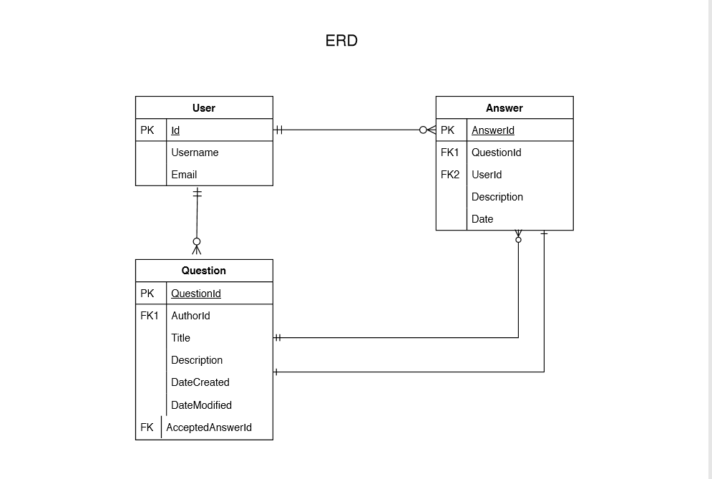

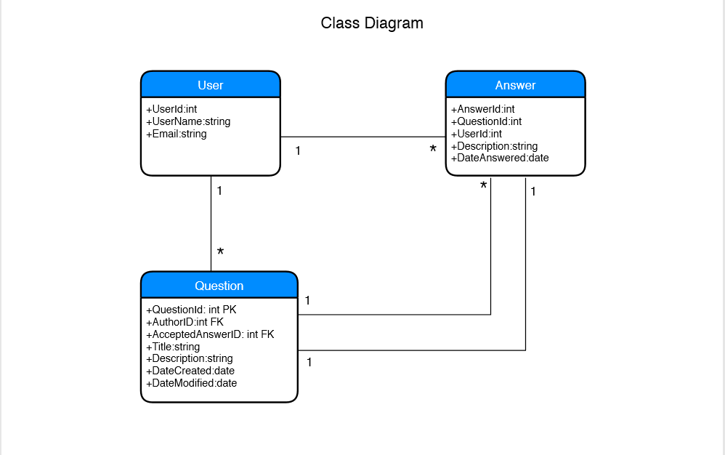

User-Stories

* As an unregistered user I want to view content/posts so that I can keep up to date or to find questions of my interest.
* As an unregistered user I want to create account/register so that I can be able to create/edit content or leave account.
* As a registered user I want to post a question so that I can get answers to my problems.
* As a registered user I want to I want to answer to a question so that I can provide my experience.
* As a registered user I want to mark answer as accepted answer so that they can see that my problem is solved or the provided answer has worked for me.
* As a registered user I want to view profile of any user so that I can view their published questions.
* As a Registered/Guest I want to view a list of questions so that so that I can see if there are any similar questions to my problem.
* As a Registered/Guest I want to view a question with answers so that I can see what the problem was and how it was solved.

Sequence Diagram

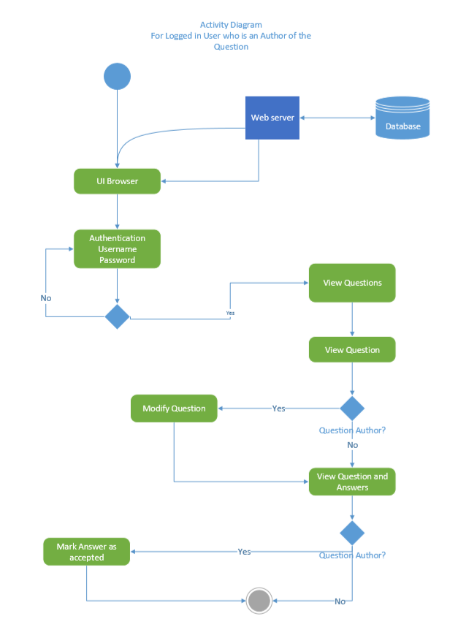

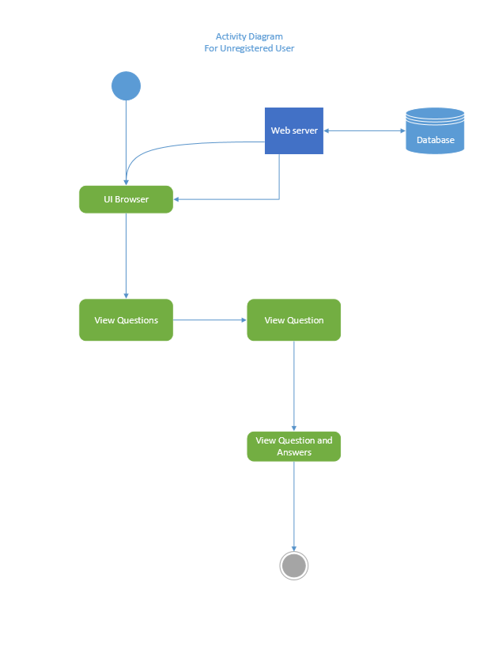

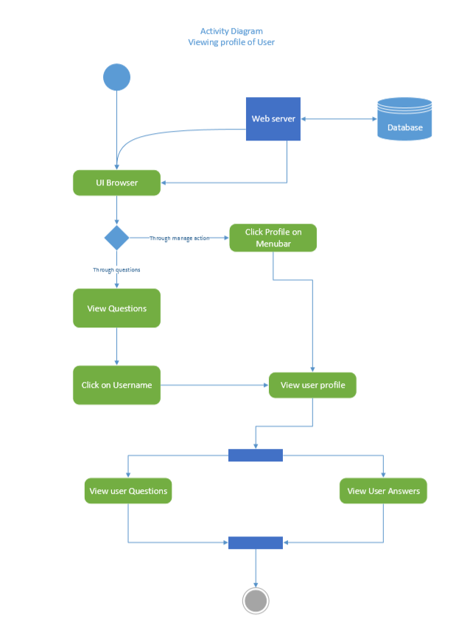

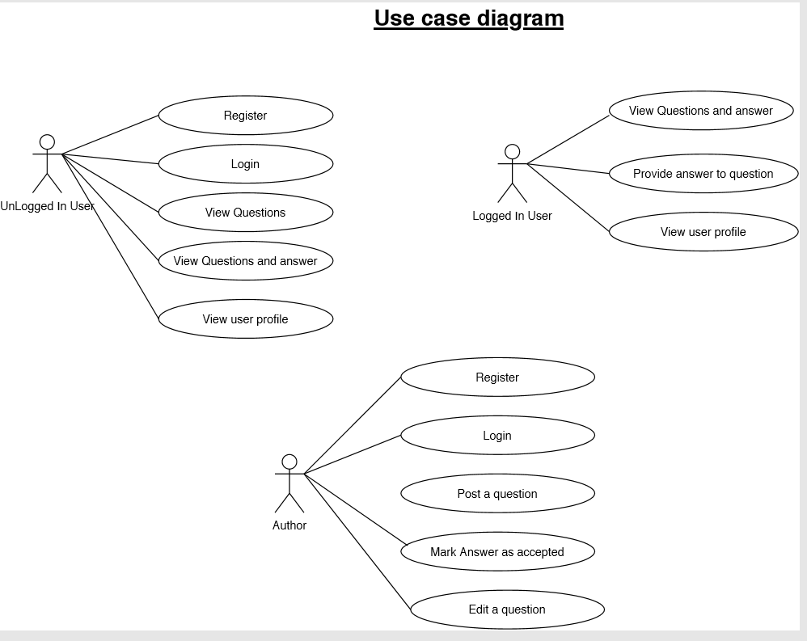

Sequence Diagrams

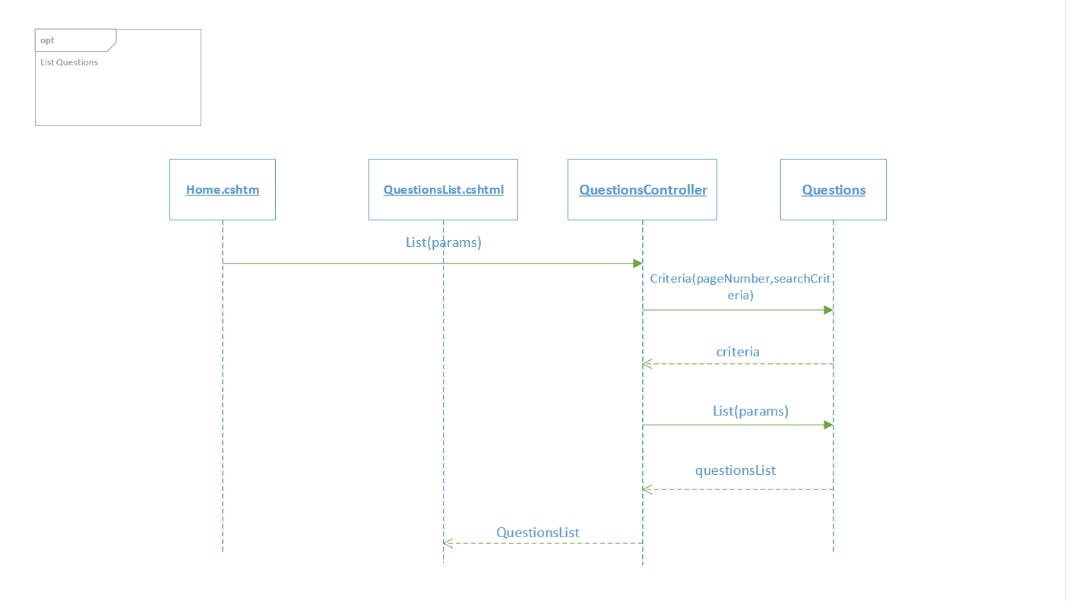

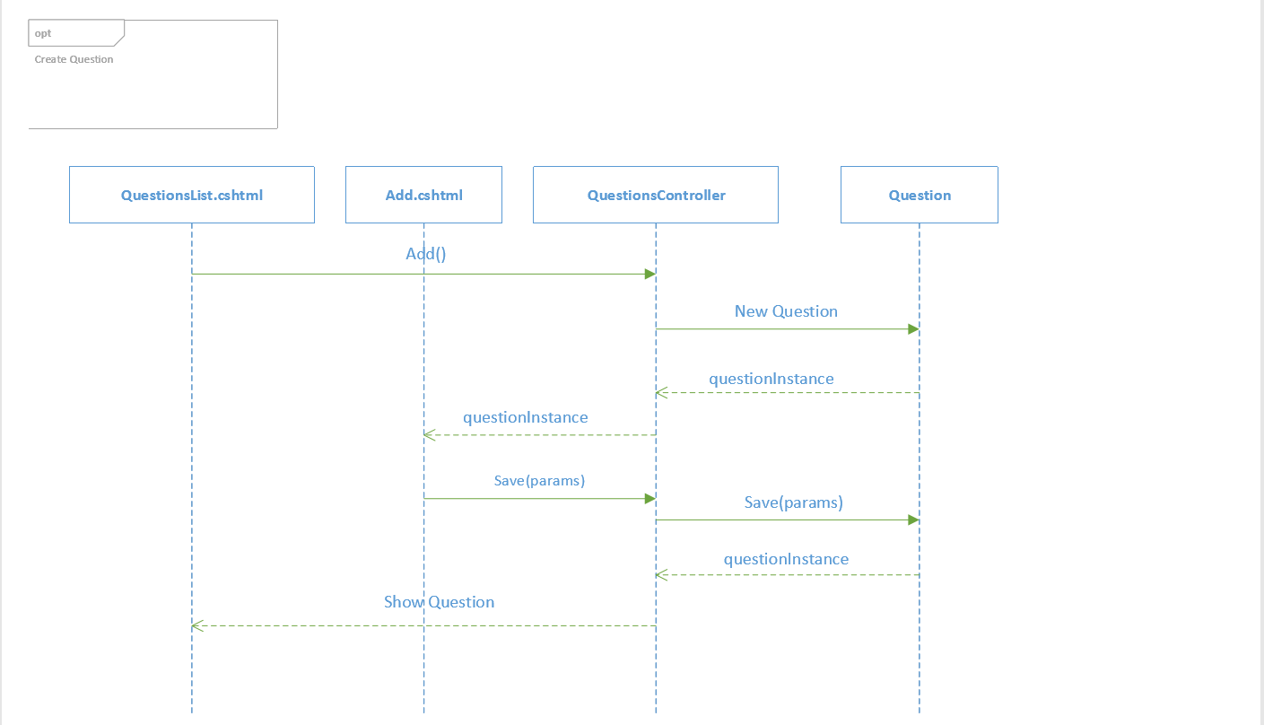

### 

### Task 2 (US 115365: SO 2, AC 1, 3) [GROUP WORK]

Design user interface wireframes for the computer program.

* Your wireframes should cover the essential use cases of the computer program
* The design must meet the specification for the function. That is, error avoidance, workplace design, document design, equipment design, dialog design, job design.
* The design must relate to current industry recommended format.
* Attach your wireframes as evidence in your POE (15)

**Attached wireframes:**

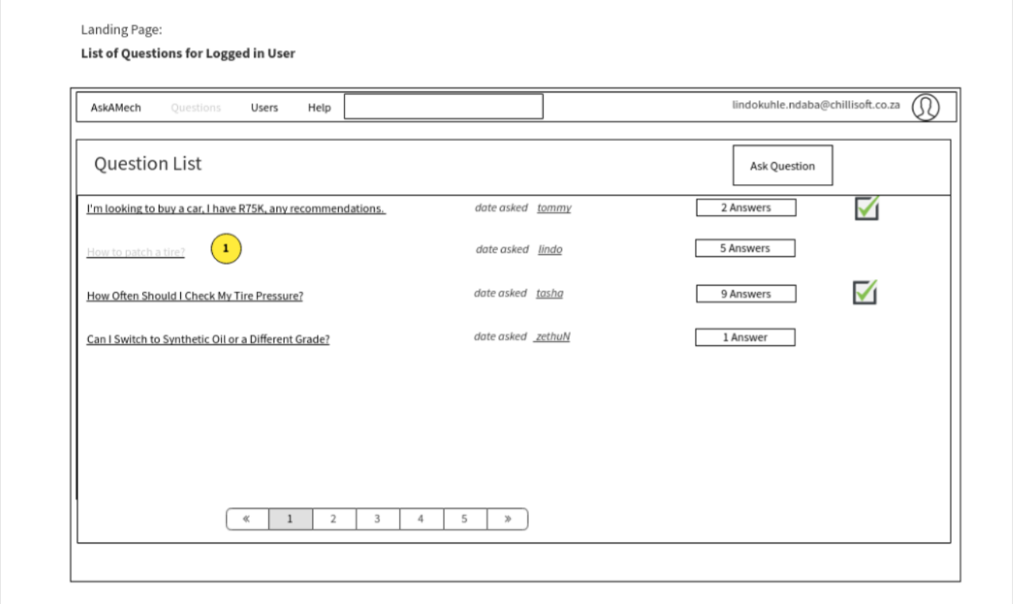

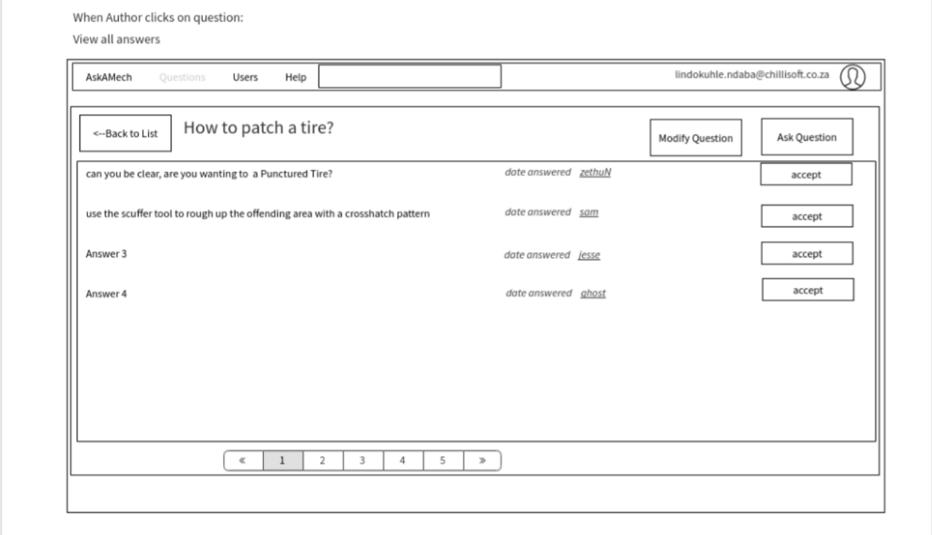

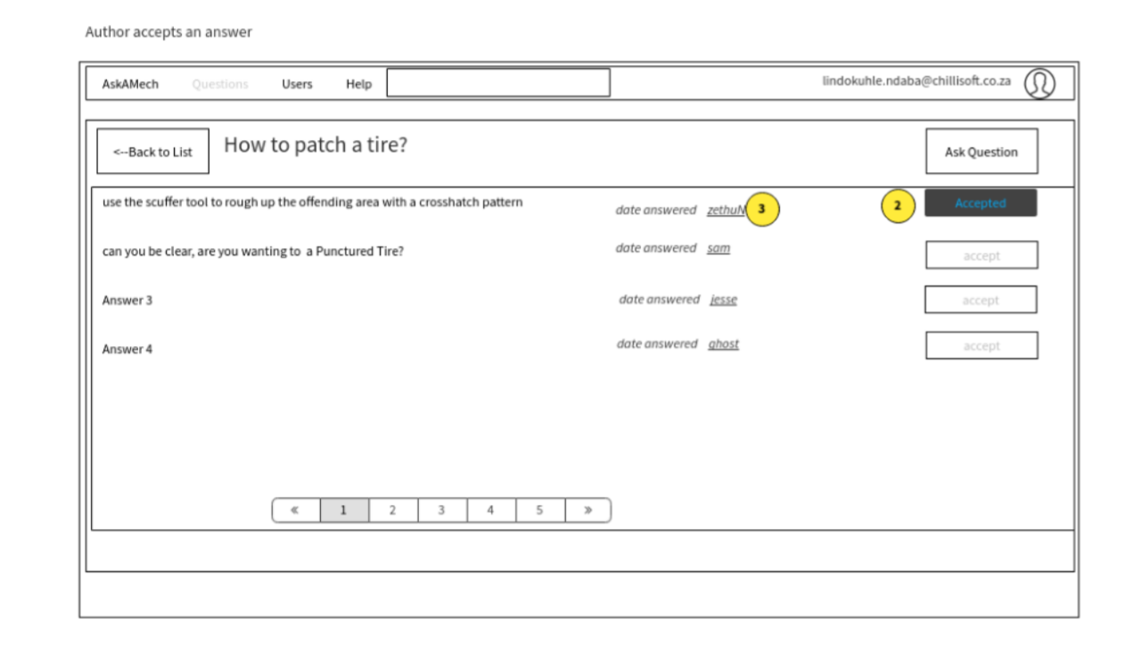

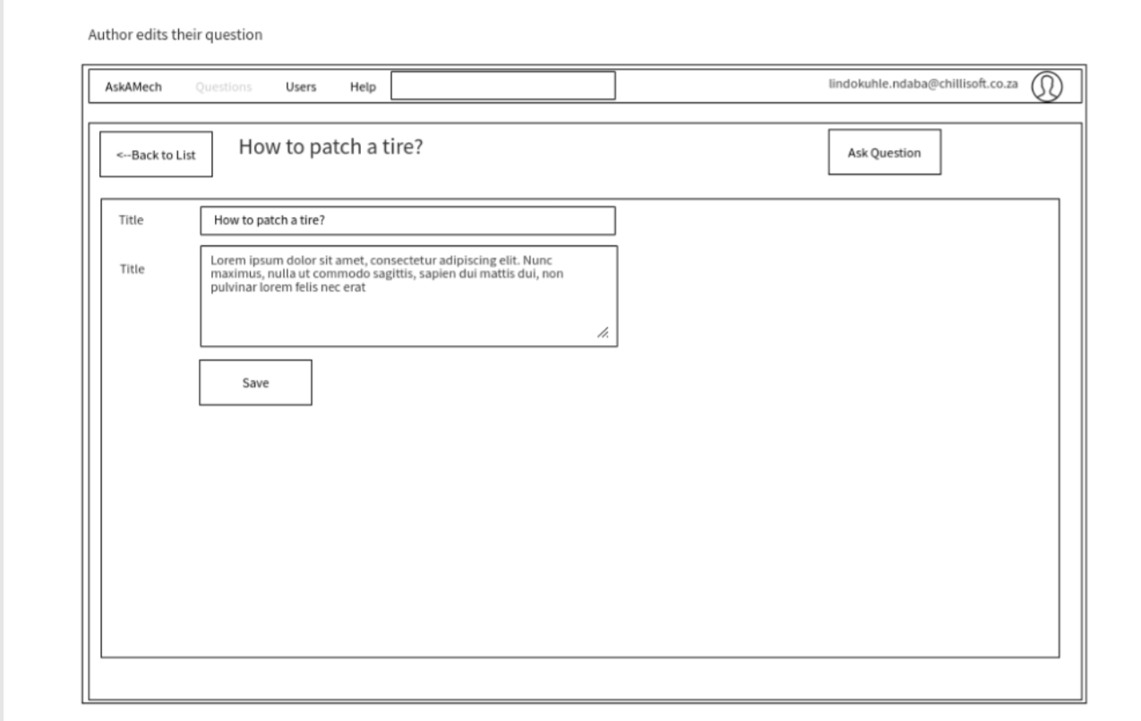

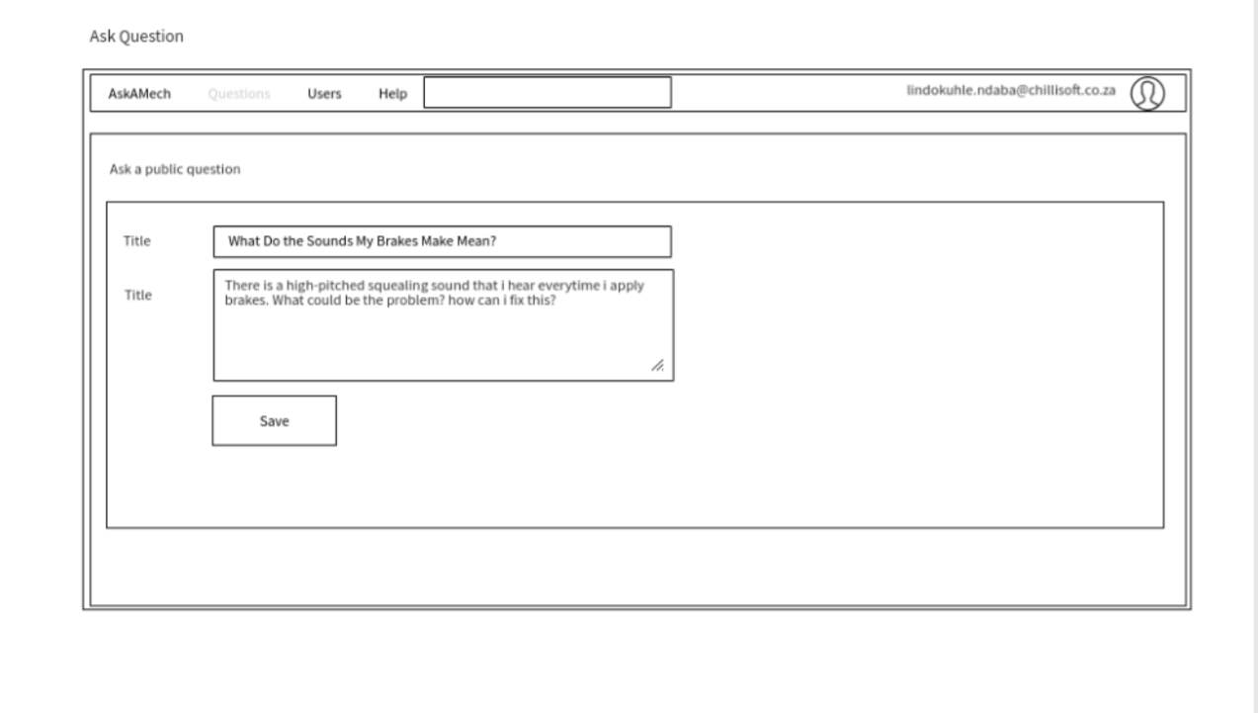

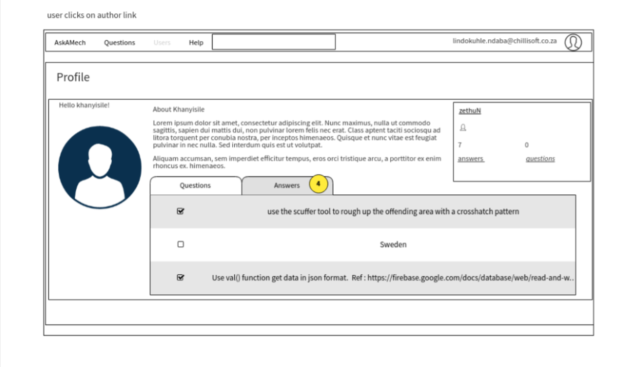

### 

### Task 3 (US 115365: SO 2, AC 2) [INDIVIDUAL WORK]

Given the wireframes that were designed as a group in Task 2 above:

1. Explain how the design can be implemented in the client’s computer environment
2. Identify the computer environment considerations that influenced the design
3. Identify some computer environments that the design would not be ideal for (9)

**Answer:**

i)

ii)

iii)

## Activity 3 – Building the Software

### Task 1 (US 115392: SO 3, AC 1, 2, 3) (US 115365: SO 3, AC 1, 2) [GROUP WORK]

You are now required to create a computer program that implements the design. Take note of the following;

* The creation must include coding from design documents.
* Names created in the program must describe the purpose of the items named.
* The creation includes conformance with design documentation.

As evidence, you must provide a link to a zip file shared through any online file sharing service without an expiry date (drop box, google drive, one drive, etc.) (30)

*File sharing URL to project zip file (all code and database scripts/backup):*

…

In order to prove that you have contributed to this aspect of the project the assessor/facilitator will arrange an interview with you (in person or over video conferencing) to ascertain the authenticity of the submission with regard to the following:

|  |
| --- |
| The learner was able to identify, explain and answer questions regarding a section of code that they contributed to the project. |

The assessor/facilitator must complete the attached evaluation checklist.

(The checklist is attached at the end of this Assessment Instrument).

### Task 2 (US 115365: SO 3, AC 1, 2) [INDIVIDUAL WORK]

Examine the computer program that you created to implement the design as compared to your original designs. Describe the differences and similarities between the design and the implementation as they relate to the following:

1. Does the function format correspond to the design?
2. Does the function behaviour correspond to the design? (10)

**Answer:**

i)

ii)

NB. Take screenshots of the implemented designs (screens, database diagrams, etc.) and attach them in your POE below.

*(tip: use “win key” + shift + s to capture the specific section of the screen and then paste it here)*

### Task 3 (US 115368: SO 1, AC 3, 7) [INDIVIDUAL WORK]

Find a section of styled html from your project and its related css (just the selectors that are applicable).

1. *Describe* the styles that have been applied to the html elements in the snippet and how they affect the display of the elements.
2. Include the HTML, CSS and Screenshot of the rendered output for the section of styled html in your POE.

(10)

**Answer:**i)

ii) The snippets and a screenshot are included in the blocks below.

HTML:

CSS:

SCREENSHOT:  
*(tip: use “win key” + shift + s to capture the specific section of the screen and then paste it here)*

### Task 4 (US 115368: SO 2, AC 3, 4) [INDIVIDUAL WORK]

With reference to the computer program that you have created, please answer the following:

1. *Describe* the underlying technologies that link databases and web sites.
2. *Describe* known methods of linking web pages to back-end proprietary applications.

(10)

**Answer:**i)

ii)

## Activity 4 – Testing

Using the computer program that you have developed, you are required to test the computer program.

### Task 1 (US 115392: SO 4, AC 1, 2) [GROUP WORK]

Develop and attach a testing strategy. (6)

(Tip: Follow the guidelines in the US 115392 learner manual for developing your testing strategy.  
Take note of the difference between the test strategy and the test plan, which you will develop next)

### Task 2 (US 115384: SO 1, AC 1, 2, 3, 4) [INDIVIDUAL WORK]

In accordance with your test strategy:

1. Develop and attach a testing plan

* Include your test case specifications
* Include methods of Black Box and White Box Testing

1. Test the application, following the the operational steps identified in the test plan.
2. The testing must use input data as specified in the test plan.
3. The testing outlines the deviations from the test plan with explanations.
4. The testing must follow industry standard operating procedures.
5. Record the testing results as you perform the testing (these will be used for Task 3)

**Note:** Attach your test plan and test case specifications in your POE (20)

### Task 3 (US 115384: SO 2, AC 1, 2, 3, 4) (US 115392: SO 4, AC 3) [INDIVIDUAL WORK]

You are required to record the results of the tests that you conducted in Task 2 above.

1. Attach the test log from your testing of the application
2. Create and attach a test report summarizing the results
3. Create and attach test incident reports for any test failures.
4. Ensure that the records:

* Are provided for all tests executed and that variations from expected test results are given.
* Results are recorded in a manner that they can be reproduced and reviewed

**Note:** Attach your test log, test report, and test incident reports in your POE. (15)

### Task 4 (US 115384: SO 3, AC 1, 2) [INDIVIDUAL WORK]

You are now required to review the testing process against acceptable standards in the organization or industry.

1. Review the testing process and suggest areas of improvements. (10)
2. Explain whether the testing process follows standard procedures and policy. (8)

**Answer:**

i)

ii)

## Activity 5 – Implementation / Installation

You are required to prepare to implement the program in order to meet the needs of the business.

### Task 1 (US 115392: SO 5, AC 1) [INDIVIDUAL WORK]

Explain how you shall check that the implementation complies with user expectations. (6)

**Answer:**

### Task 2 (US 115392: SO 5, AC 2) [INDIVIDUAL WORK]

Develop a training plan for the small business owner and the users of the system. (8)

**Answer:**

### Task 3 (US 115392: SO 5, AC 3) [INDIVIDUAL WORK]

Develop a plan for the installation process of the program. (5)

**Answer:**

## Activity 6 - Documentation

### Task 1 (US 115392: SO 6, AC 1, 2, 3, 4) (US 115388: SO 2, AC 1, 2, 3) [GROUP WORK]

Using the computer program that you have developed, you are required to design, create and attach the following program documents in your POE.

* User Manual
* System Architecture Document
* System Maintenance Guide
* Technical Manual  
  The Technical Manual should include: Program purpose, programming standards, design approach, any other information that would be relevant to a programmer working on the program

Take note of the following when creating the documents;

* The documentation is created according to industry standard design.
* The documentation created is structured sensibly, defining how program specifications have been met.

(20)

Answers

1. **Introduction**

This introduction provides an overview of the System Architecture Document for AskAMech. It includes the purpose, scope, target audience, design approach, main component design and high-level system design considerations of the system.

**Document scope and Purpose**

This document provides a description of the technical design for AskAMech – Q&A Forum. This document’s primary purpose is to describe the technical vision for how business requirements will be realized. This document provides an architectural overview of the system to depict different aspects of the system. This document also functions as a foundational reference point for developers.

Please note that this is a baseline document and may be updated as development progresses.

**Target Audience**

This document is targeted (but not limited) to technical stakeholders:

* Development Team
* IT Management
* Support Staff

It is assumed that the reader has a technical background in software design and development.

**Acronyms/Abbreviations**

|  |  |
| --- | --- |
| **Acronym** | **Meaning** |
|  |  |
|  |  |

**Reference Documents**

* System requirement document of AskAMech
* Feasibility Study

**System Environment**

* Development: Visual Studio 2017 + Dotnet 2.2
* Unit Test: NUnit
* Diagrams: Visio 2016 /Draw.IO
* Database Management: SQL Server Management:
* Database: SQL

**Design Approach**

The design approach used here is based on the following:

**Data Flow Design**

The data flow of the ASKAMECH is web-based. Entity Framework technologies will be utilized to retrieve data from SQL database to be displayed by the Web portal user interface and would also allow updating the data where applicable.

**Architecture Design**

The application will follow a Four Layer Architecture so that the objects in the system as a whole can be organized to best separate concerns and prepare for distribution and reuse. A principal advantage to this design is the relative stability of the components as seen by the applications developer. Implementations may change considerably to enhance the performance or in response to changes in the architecture. These changes are less likely to cause major impact to the applications’ programs.

**UI Design**

Wire Frames are used for UI design. Wire frames are an effective tool for collecting and presenting functionality, navigation, and content of an application or web site. Annotations or notes attached to elements or widgets on the wire frame help to communicate specific functions.

**Design Patterns**

This application is designed as an object-oriented system for a web-based architecture using four-layer architecture by factoring application classes into the following layers:

**The Presentation layer:** This is the layer where the physical window and widgetobjects live. It will also contain Controller classes as in classical MVC. Any new user interface widgets developed for this application are put in this layer.

**The Domain Mode:** Most objects identified in the OO analysis and design will reside.To a great extent, the objects in this layer can be application-independent. Generic objects may be used in this application to reap the benefits of Object-Oriented programming.

**The Command layer:** This willcontain the application login and make use of domain classes onto a wider range and will be more flexible in the creation of possibly editing of data from the infrastructure layer.

**The Infrastructure layer**: The data is managed by SQL.

In Addition;

**The Command Tests layer**: This is the layer that will consist of all the application tests that will be mainly focused but not limited to commands. To great extent this layer will use and substitute some of the implementations from the command layer and make use of Domain models as well.

**AskAMech High level View**

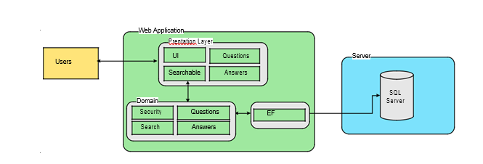

1. **Modules**

General Search

The general search included that retrieve records from the database according to user specified search criteria. Further, the search may encompass other information collections like on-screen data.

Q&A forum

Question

The questions included the management of questions. The granted user can add, edit and modify the questions within his scope. The granted user can also add, delete or modify a specific question that they have asked. For each question, there should be only one accepted answer.

Answers

The answers included the management of answers for a specific question that has been asked. The granted user can add, edit and modify the answer within his scope. Only the author of the question can mark an answer as accepted.

Profile

The profile included the management of profiles. The general user can view their profile and other users’ profiles. The granted user can also update their profile details which include changing of profile pictures.

1. **User Guide**

**end-User guide**

System Requirements

You may run the system windows interface application any OS including but not limited to Windows 10 and Windows 8 OS. The system must have SQL Server database installed to allow for connecting to the AskAMech database. You can connect using any browser such as Firefox, Chrome, Microsoft Edge.

Access to the windows application

Any user having the application executable and meeting the system requirements stipulated above can access the windows interface application. And also, any user having internet connection and using one the listed browsers can access the web interface application using the following link: <http://askamech.com>

[Login]

Access to the application is not restricted and any user can gain access to the application. Without authorization the unauthorized user can view questions and their answers, and also view user profiles. authorized users can see the latter and also have other capabilities. each user should know his user name and password to be able to ask questions and answer questions.

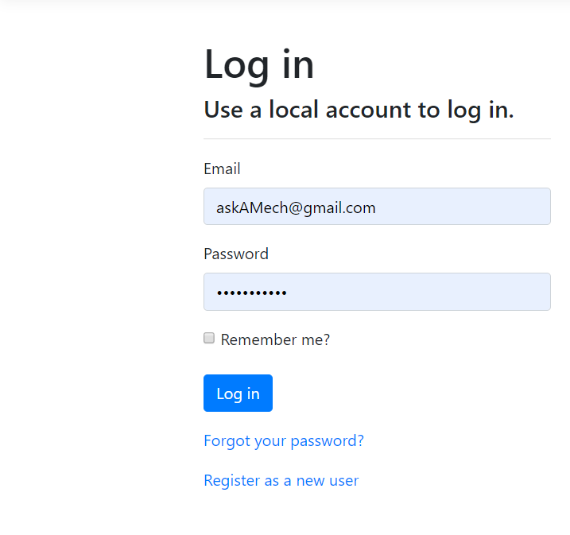

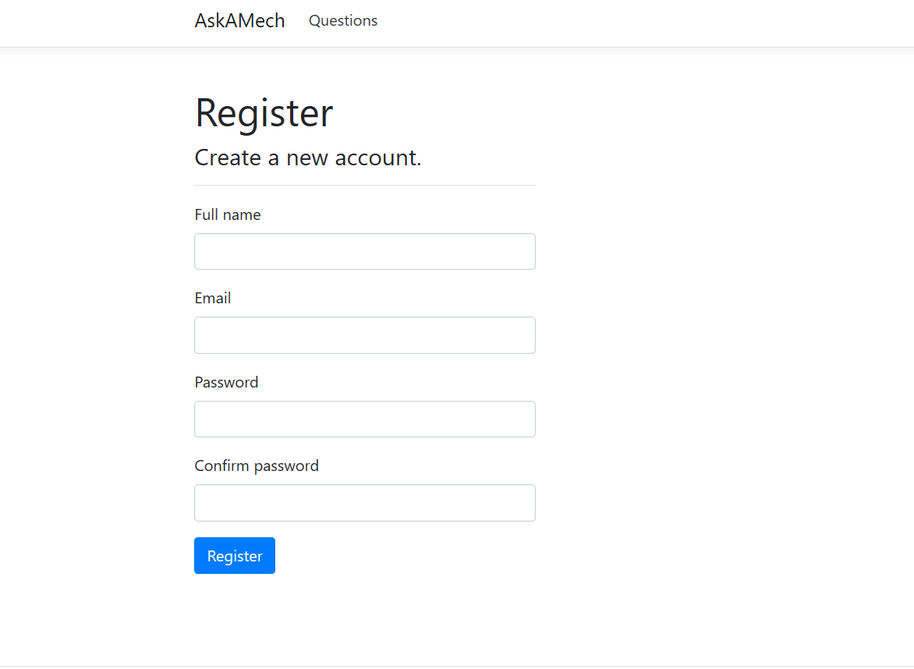

Application Main Page

After opening the application, the page below is displayed. The user can use this screen view questions. For any user (authorized or not authorized). By default, the questions page. Each question title is a link to the question and its answers.

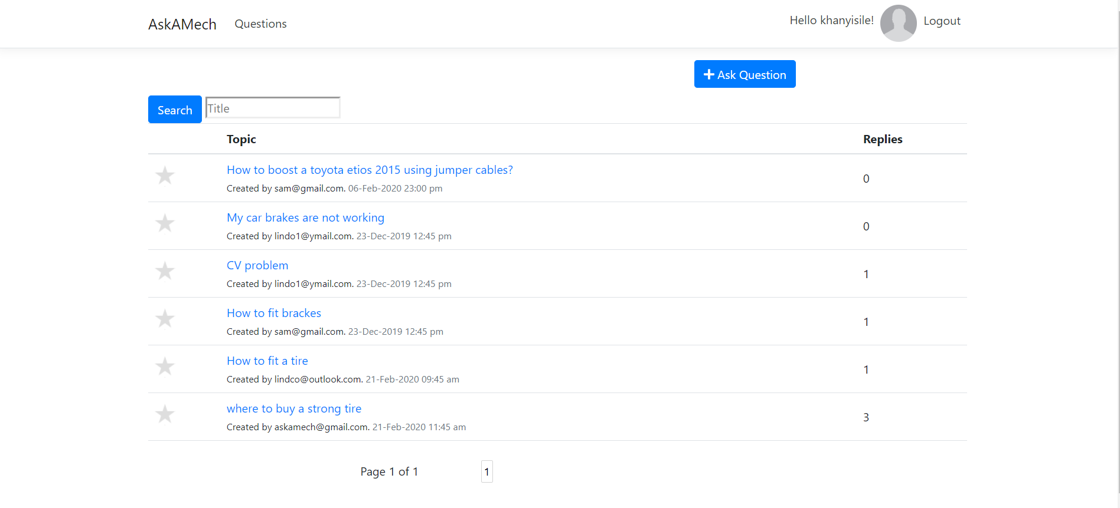

Question and its answers

By clicking on the question, the link shows you a screen with the details of the question and also all the answers that belong to that question. You can add answer to the question and view user profile by clicking on the username link.

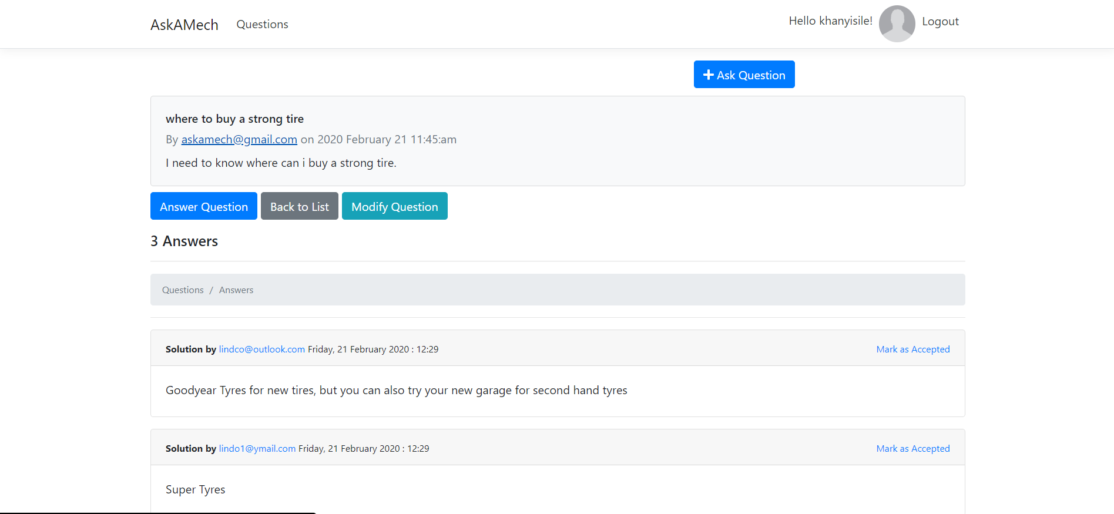

* You can provide the answer by clicking on the answer button or scroll to the bottom.
* If you are an author of the question you have ability to mark answer as accepted.
* The author of the question can modify the question.

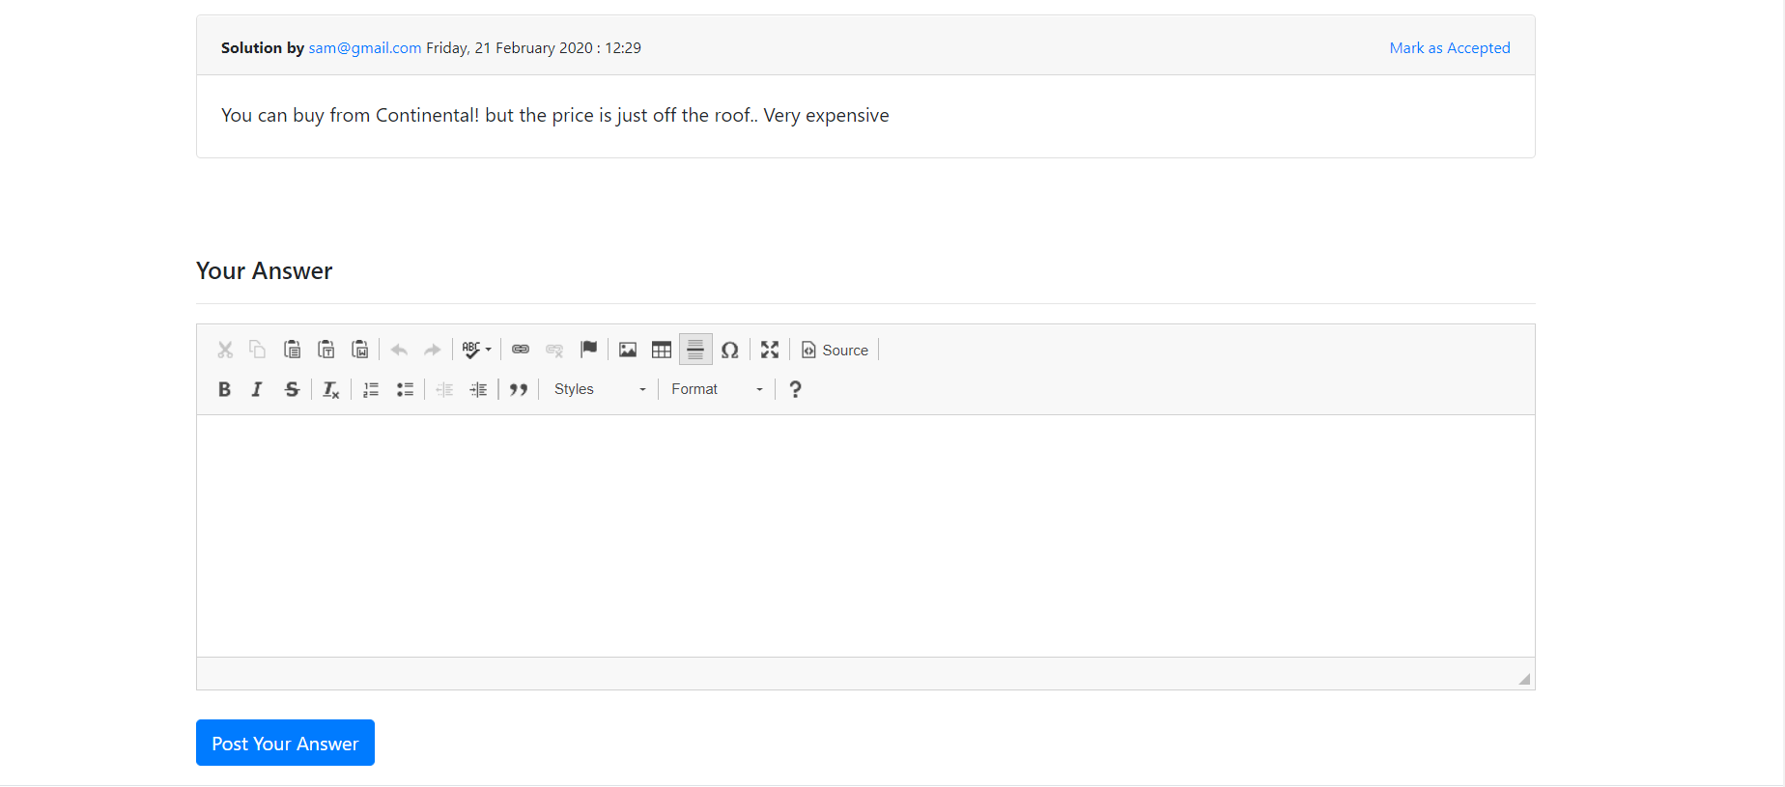

Modify question

* Click on the modify button

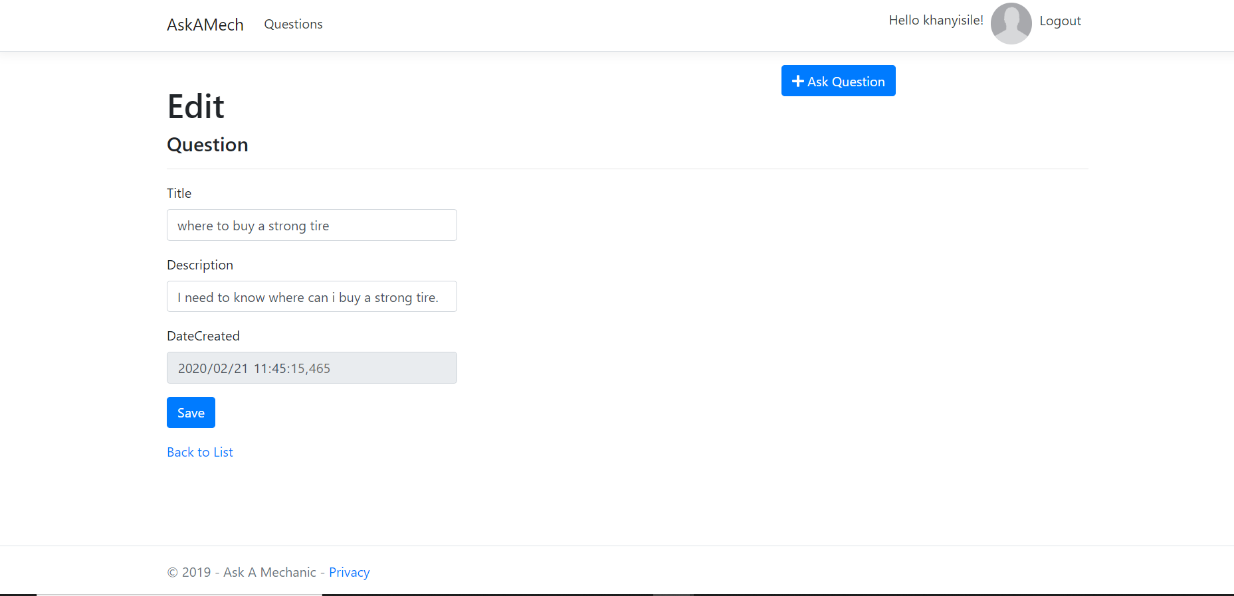

* If you are not the author of the question, you cannot mark an answer as accepted hence the link will not show.
* You cannot also modify the question.
* The actions are hidden.

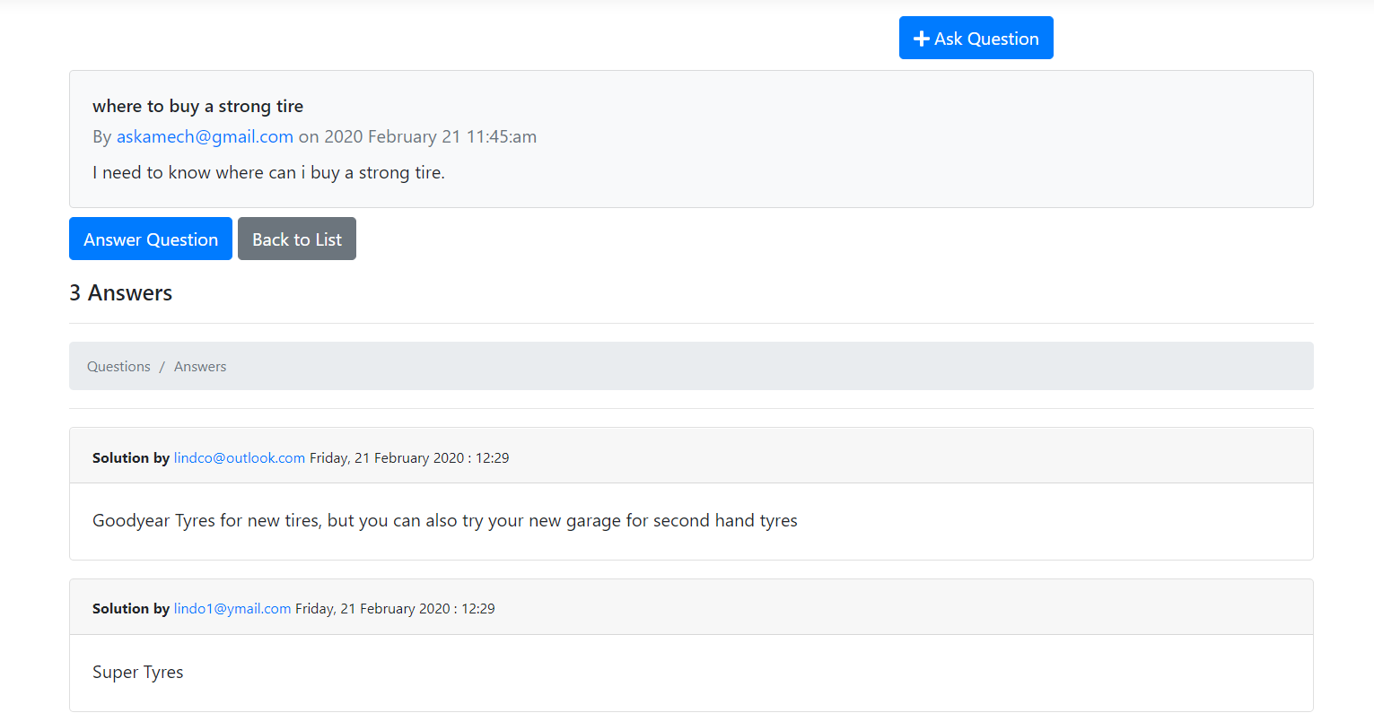

Answer Question

* Click on the answer question. It will take you to the following screen.
* Click on create button

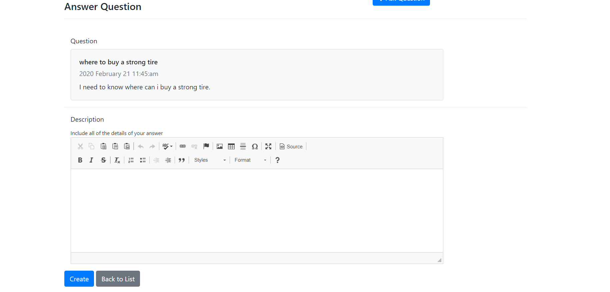

View user profile

Click on the username link next to date

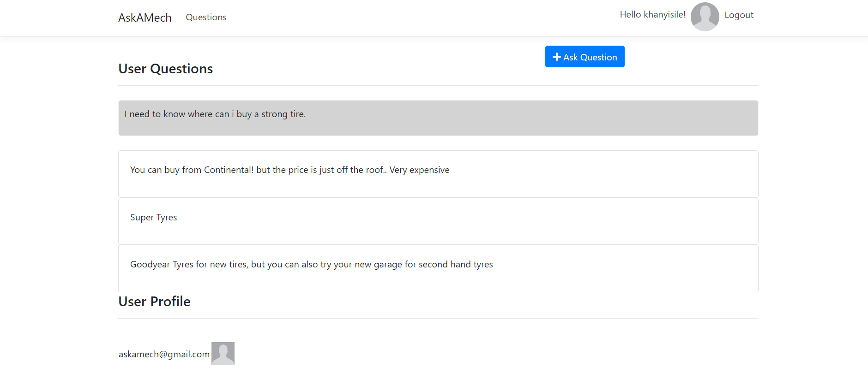

* This shows the userprofile with questions and answers provided by the user.
* Unauthorized user can view questions and answers but cannot mark answer as accepted or modify the answer

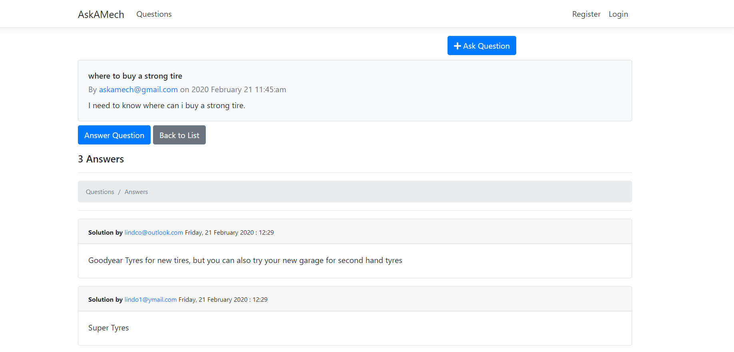

1. **Technical Document**

TARGET AUDIENCE

1. This document is targeted (but not limited) to technical stakeholders:

a. Development Team

b. IT Management

c. Support Staff

It is assumed that the reader has a technical background in software design and development.

TOOLS & TECHNOLOGIES

Visual Studio 2017, .NET Core 2.2, MVC, C#.NET, MS SQL SERVER Management 2018 , NUnit

PATTERN

1. Developed using layered-architecture approach (so that the objects in the system as a whole can be organized to best separate concerns and prepare for distribution and reuse)

a. Physical Layers

1. Presentation Layer

2. Data Layer

b. Logical Layers

1. Business Commands

2. Data Access (DbGateways)

3. Data Model

c. Unit test

1. Using Builders

2. Unit and acceptance

2. Coding and naming conventions are as per MSDN standards.

SYSTEM ENVIRONMENT

* + Development: Visual Studio
  + Unit Test: NUnit
  + Database Management: SQL Server Management Studio
  + Database: SQL
  + Version Control: GitHub

EXTERNAL LIBRARY USED

1. PeanutButter.RandomGenerators

HOW TO USE THE CODE

1. Check Visual studio 2017 is installed

2. If yes, Open the solution file

3. open the Package manager console and run “Update-database” to run the migrations.

a. In case of exception, try changing the following in your machine and check if it runs

1. connection string on appsettings.json

4. make sure AskAMech is default project.

5. Run the application.

### Task 2 (US 115388: SO 3, AC 1, AC 2) [INDIVIDUAL WORK]

You are required to review the program documentation that you have developed in question 1.

1. Review the document design and justify the style, structure, content and format used. (6)
2. Explain whether the documentation created was consistent with the computer program being documented. (6)

|  |  |
| --- | --- |
| **STUDENT NAME:** ……………………………………….  **COMPANY:** …………………………………..  **ID:** …………………………………………….. | **EVALUATION CHECKLIST**  DATE: …………………..  TIME: ………………….. |

|  |  |  |  |  |  |
| --- | --- | --- | --- | --- | --- |
| **EVALUATION CRITERIONS** | | **Met Requirements** | **Did Not Meet Requirements** | **COMMENTS OR ACTION REQUIRED** | |
| **ACTIVITY 3 (Task 1) - US 115392: SO 3, AC 1, 2, 3** | | | | | |
| The computer program includes coding from design documents. | |  |  |  | |
| Names created in the program must describe the purpose of the items named. | |  |  |  | |
| The creation includes conformance with design documentation. | |  |  |  | |
| **ACTIVITY 3 (Task 1 & 2) - US 115365: SO 3, AC 1, 2** | | | | | |
| The creation ensures that the function format corresponds to the design. | |  |  |  | |
| The creation ensures that the function behaviour corresponds to the design. | |  |  |  | |
| **AUTHENTICITY** | |  |  |  | |
| The learner was able to identify, explain and answer questions regarding a section of code that they contributed to the project. | |  |  |  | |
| **GENERAL COMMENTS:** | | | | | |
|  | | | | | |
| Date…………………….. | Time started……………….. | | | | Time completed………………. |
| **FACILITATOR / SUPERVISOR NAME**  **………………………………** | **FACILITATOR / SUPERVISOR SIGNATURE**  **…………………………………….** | | | | **ASSESSOR ENDORSEMENT**  **(SIGNATURE)**  **………………………………….** |

**(5 marks per evaluation criterion) TOTAL MARK 30**